# **Learning Journal - Unit 8**

Computer Science, University of the People

CS 2203-01 Databases 1 - AY2024-T3

Instructor, Irfan Rashid Thoker

March 25, 2024

This week I was given the task of writing the query scripts for the following requests:

Also even though not required I’m attaching both the scripts and a screenshot (partial if to large) of the results.

1. Get all the orders placed by a specific customer. CustomerID for this customer is MAGAA

SELECT *

FROM tblOrders

WHERE CustomerID = 'MAGAA';

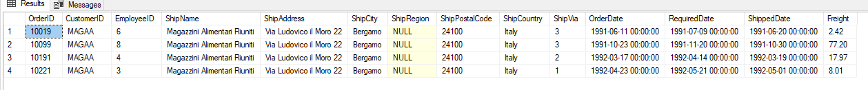

1. Show customers whose ContactTitle is not Sales Associate. Display CustomerID, CompanyName, Contact Name, and ContactTitle

SELECT

    CustomerID,

    CompanyName,

    ContactName,

    ContactTitle

FROM tblCustomers

WHERE ContactTitle <> 'Sales Associate';

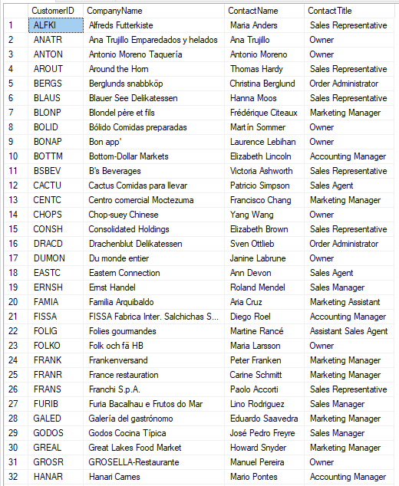

Continued beyond image …

1. Show customers who bought products where the EnglishName includes the string “chocolate”. Display CustomerID, CompanyName, ProductID, ProductName, and EnglishName

SELECT DISTINCT

    c.CustomerID,

    c.CompanyName,

    p.ProductID,

    p.ProductName,

    p.EnglishName

FROM tblCustomers c

    JOIN tblOrders o ON c.CustomerID = o.CustomerID

    JOIN tblOrderDetails od ON o.OrderID = od.OrderID

    JOIN tblProducts p ON od.ProductID = p.ProductID

WHERE p.EnglishName LIKE '%chocolate%';

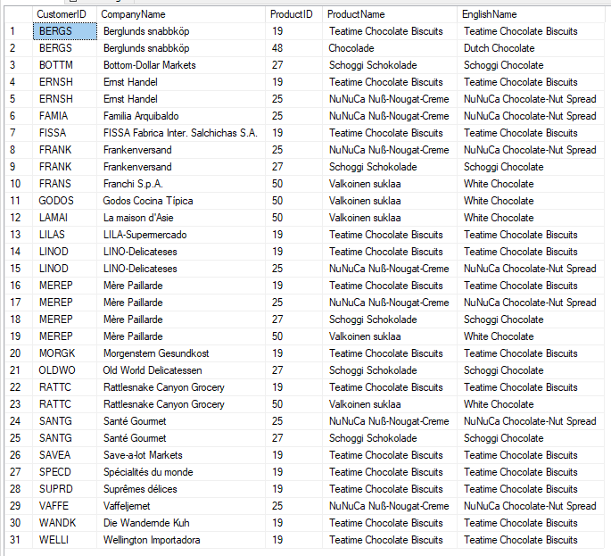

1. Show products which were bought by customers from Italy or USA. ”. Display CustomerID, CompanyName, ShipCountry, ProductID, ProductName, and EnglishName

SELECT DISTINCT

    c.CustomerID,

    c.CompanyName,

    o.ShipCountry,

    p.ProductID,

    p.ProductName,

    p.EnglishName

FROM tblCustomers c

    JOIN tblOrders o ON c.CustomerID = o.CustomerID

    JOIN tblOrderDetails od ON o.OrderID = od.OrderID

    JOIN tblProducts p ON od.ProductID = p.ProductID

WHERE o.ShipCountry IN ('Italy', 'USA');

Continued beyond image …

1. Show total price of each product in each order. Note that there is not a column named as total price. You should calculate it and create a column named as TotalPrice. Display OrderID, ProductID, ProductName, UnitPrice, Quantity, Discount, and TotalPrice

SELECT

    od.OrderID,

    od.ProductID,

    p.ProductName,

    od.UnitPrice,

    od.Quantity,

    od.Discount,

    (od.UnitPrice * od.Quantity * (1 - od.Discount)) AS TotalPrice

FROM tblOrderDetails od

    JOIN tblProducts p ON od.ProductID = p.ProductID;

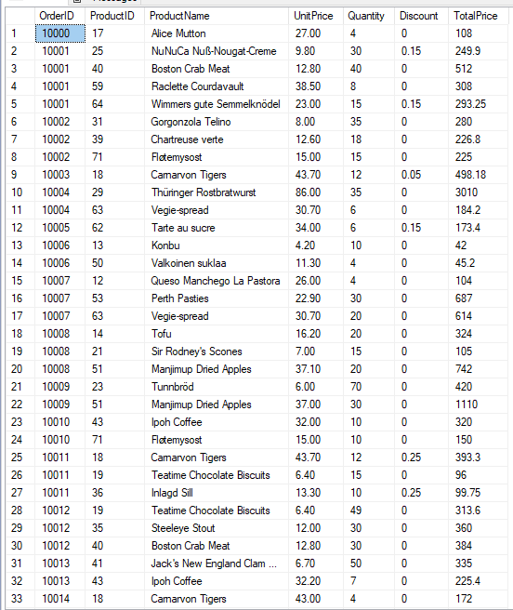

Continued beyond image …

1. Show how many products there are in each category and show the results in ascending order by the total number of products. Display CategoryName, and TotalProducts

SELECT CategoryID, COUNT(p.ProductID) AS TotalProducts

FROM tblProducts p

GROUP BY CategoryID

ORDER BY TotalProducts ASC;

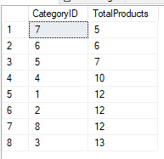

1. Show the total number of customers in each City. Display Country, City, TotalCustomers

SELECT

    Country,

    City,

    COUNT(CustomerID) AS TotalCustomers

FROM tblCustomers

GROUP BY Country, City;

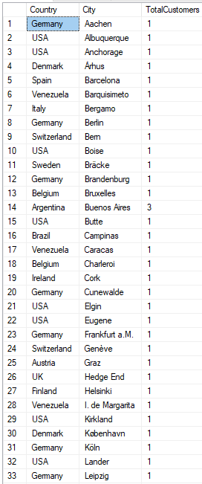

Continued beyond image …

1. Show the orders which were shipped late than the actual required date. Display OrderID, OrderDate, RequiredDate, and ShippedDate

SELECT

    OrderID,

    OrderDate,

    RequiredDate,

    ShippedDate

FROM tblOrders

WHERE ShippedDate > RequiredDate;

## References

* Learning Guide Unit 1-8  
  <https://my.uopeople.edu/course/view.php?id=7455>
* Sharma, N., Perniu, L., Chong, R. F., Iyer, A., Nandan, C., Mitea, A. C., Nonvinkere, M. & Danubianu, M. (2010). Database fundamentals. IBM Canada.  
  <https://my.uopeople.edu/pluginfile.php/1827130/mod_book/chapter/484065/Database_Fundamentals.pdf>
* Watt, A., & Eng, N. (2014). Database design,  2nd ed. BCcampus, BC Open Textbook Project.   
  <https://opentextbc.ca/dbdesign01/>  
  <https://my.uopeople.edu/pluginfile.php/1827130/mod_book/chapter/484065/Database-Design-2nd-Edition-1560272109.pdf>